Basics of using formulas

Recognise this sort of thing? (you don’t need to work it out now )
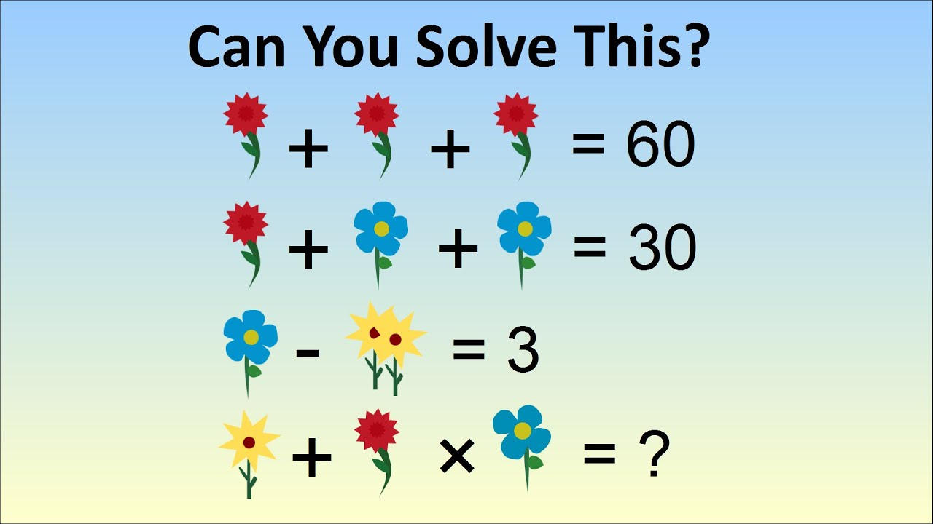

This is algebra! Algebra is a process of using a formula to solve a problem.

To make it easier, we use letters, so it looks like this:

R + R + R = 60
R + B + B = 30
B – 2Y = 3
Y + R x B = ?

A Puzzle
What is the missing number?
 | − | 2 | = | 4
OK, the answer is 6, right? Because 6 − 2 = 4.
Well, in Algebra we don't use blank boxes, we use a letter (usually an x or y, but any letter is fine).

So we write:
x | − | 2 | = | 4

The letter (in this case an x) just means "we don't know this yet", and is often called the unknown or the variable.

And when we solve it we write:
x | = | 6

Why Use a Letter?
 | Because:
 | it is easier to write "x" than drawing empty boxes (and easier to say "x" than "the empty box").
 | if there are several empty boxes (several "unknowns") we can use a different letter for each one.
So x is simply better than having an empty box. We aren't trying to make words with it!
And it doesn't have to be x, it could be y or w ... or any letter or symbol we like.

How to Solve
While some may be simple and you can do it in your head, others may be harder. So we need to follow a process- we will practice on the easy ones:
x | − | 2 | = | 4

- Work out what to remove to get "x = ..."
- Remove it by doing the opposite (adding is the opposite of subtracting, dividing is the opposite of multiplying)
- Do that to both sides

Opposites
Plus (+) opposite to minus 9(-)
Multiply (x) opposite to divide (÷)

Here is an example:
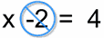
We want to remove the "−2"

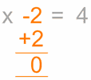

To remove it, do the opposite, in this case add 2

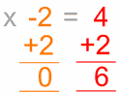

Do it to both sides

Which is ...

Solved!

Why did we add 2 to both sides?

To "keep the balance"...
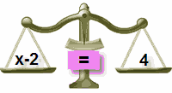
We want to remove the "−2"

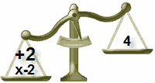

To remove it, do the opposite, in this case add 2

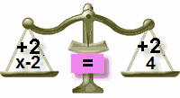

Do it to both sides

Just remember this:
To keep the balance, what we do to one side of the "="
we should also do to the other side!

Another Puzzle

Solve this one:
x | + | 5 | = | 12

What we want is an answer like "x = ...", but the +5 is in the way of that!

We want to remove the "+5"

X + = 12
____
0

To remove it, do the opposite,

X + 5 = 12
____ = ____
0 =

Do it to both sides

X + 0 = ____

Which is ...

Solved!
X = ____ !!

But letters can also represent things we could know, and we could ‘substitute’ values we know to find out those we do not.

For example:
- We want to know how many apples were in the basket this morning (x)
- We know there are 15 apples are in a basket now (b)
- 3 apples eaten (e)
b + e = x
So we want to work out

- b = 15
15 + 3 = x
- e = 3
- remove the ______
- Do the opposite to the left side:
- Now do it to the right side:
- Which is:

Your turn:

n + 3 = 24  ____ = ____  0 = | n = ____ | p - 7 = 42  ____ = ____  0 = | p = ____
s + 6 = 54  ____ = ____  0 = | s = ____ | t - 4 = 28  ____ = ____  0 = | t = ____
t + 2 = 16  ____ = ____  0 = | t = ____ | w - 8 = 32  ____ = ____  0 = | w = ____

