Maths: Index laws 7/5/20
Answer these questions as we go through the work
- What is an index?

- Give me an example of an index applied to a whole number

- What do indices show?

- What does a⁴ mean?

- How many laws are there?

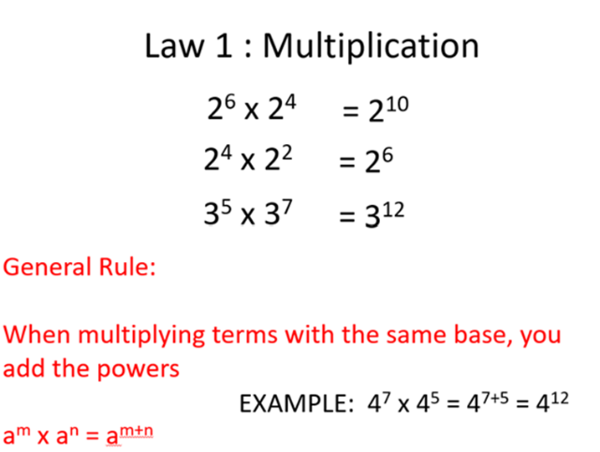

5⁷ x 5⁴ =

6³ x 6² =

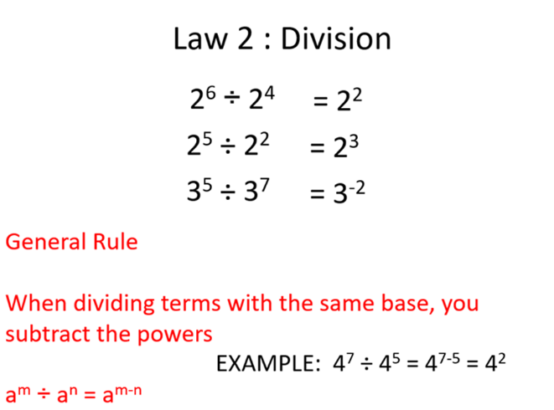

5⁷ ÷ 5⁴ =

6³ ÷ 6² =

